2. Common Elements Between Two Arrays

Aim
To write a Python program to find the common elements between two arrays.

Algorithm
- Start.
- Create two arrays containing elements.
- Create an empty list to store common elements.
- Take each element from the first array.
- Check whether the element exists in the second array.
- If it exists, add it to the common elements list.
- Display the common elements.
- Stop.

Procedure
- Open Python IDLE, VS Code, or an online Python compiler.
- Create two arrays with suitable values.
- Create an empty list called common.
- Use a for loop to access elements of the first array.
- Use the in operator to check whether each element is present in the second array.
- Store the matching elements in the common list.
- Display the common elements.
- Execute the program and verify the result.
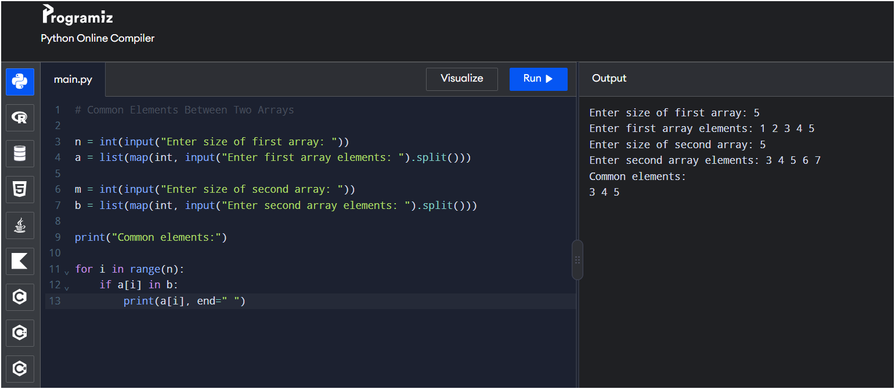

Result
Thus, the Python program successfully finds and displays the common elements present in both arrays.

